**SENIOR ONE PHYSICS TEST, TERM –TWO**

**TIME 1 HOUR**

**ATTEMPT ALL QUESTIONS**

**ITEM ONE**

Two boys, John and Paul picked a piece of glittering rectangular block along the way while they were going home. On reaching home, their elder brother Martin told them that it was a block of copper because he saw on its pack having **(density =2.5g/m3)** . However John still doubted what Martin told them because there was no scientific evidence.

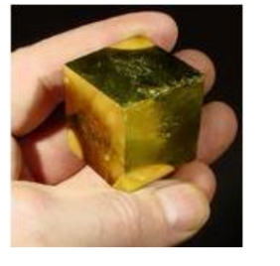

As student of physics;

1. Design a simple write up that will help this boy to confirm what their brother told them.
2. Help them to know if it was a real copper if its sides were found out to be of mass **1.6 g** and sides **2.4cm** by **1.5cm** by **1.8cm**.

**ITEM ONE**

In one of the villages in Mbale district, there is a primary school whose P.7 classroom block is near an old almost full pit latrine belonging to one of the homes neighboring the school. Students always complain about the bad smell from the latrine more so during sunny days.

The head teacher tried to approach the neighbors about this issue but they say they have nothing to do since it’s the only latrine they have.

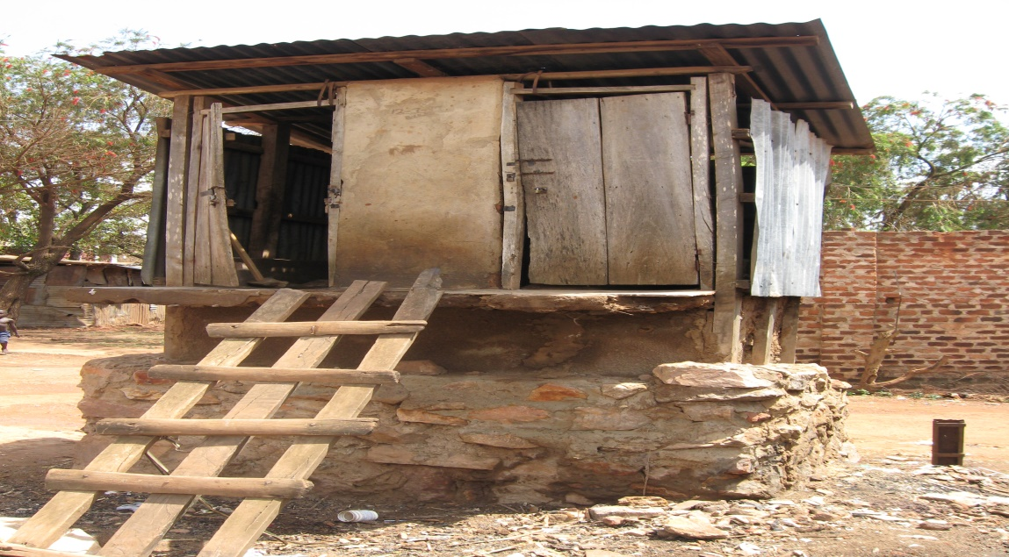

As a student of physics;

1. Explain how the smell reaches the classroom
2. Explain why the bad smell is high during sunny days
3. Advise on how this challenge is overcome.